ASIE Celebrates National Engineers Week
Added by Indo American News on February 28, 2013.
Saved under Business
Tags: Engineers, Houston

Share This Post
FacebookTwitterEmailGoogleRSS
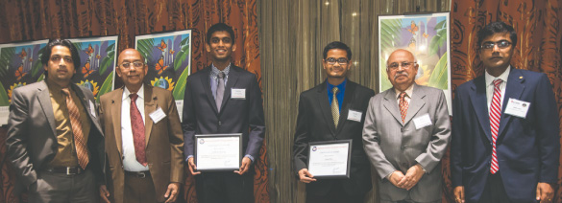
“Indian Engineers Engineering the Future” award recipients Navin Krishnasing and Sujan Patel with ASIE memebrs
By Dinesh Shah
The year 2013 started very busy for American Society of Indian Engineers (ASIE). In January, under the leadership of newly elected President Vishal Merchant, the year 2013 Executive committee was formed, which included Showeri Nandagiri as Vice president, Sekhar Ambadapudi as Secretary, and Karthik Balasubramanian as Treasurer. The current Board of Directors are Madhu Kilambi, Amal Dutta, Raj Basavaraju, Rajesh Tolikonda, and Chetan Vyas. The Board of Advisors include Srinivas Chintalapati, Hasmukh Doshi, Dinesh D. Shah, Virendra K Bansal, and Mahesh Wadhwa.
On February 2, ASIE volunteers participated at MATHCOUNTS competition sponsored by Texas Society of Professional Engineers (TBPE), which was held at Flour Corp in Sugar Land, by serving as Proctors and Graders. MATHCOUNTS is a national math enrichment, coaching & competition program that promotes middle school mathematics achievement in every U.S. state & territory. Schools select students to compete individually or as part of a team in one of the more than 500 written and oral competitions held nationwide. Top students advance to the state, and ultimately, national level.
On February 15, ASIE organized a two part event at Mayuri Restaurant, which was attended by over sixty members and was sponsored by Geotech Engineering and KIT professionals. The topic for the seminar was “Problem solving 102” by Dr. Saidas M. Ranade, who has obtained Ph.D. in Chemical Engineering from University of Houston. The second part of the event was meet and greet with Indian Consul General Parvathaneni Harish.
The National Engineers Week 2013, known as EWeek was celebrated during February 17 to 23. The theme for the event was “Celebrate Awesome”, and it was definitely celebrated awesome and enabled the UH engineering students and organizations to receive an awesome about of money and recognition. About $57,000 was awarded to 72 students and 5 organizations from corporations, professional engineering organizations, Cougar engineers, and friends of UH. The 9-year total of cash awards passed the quarter million dollar mark at about $268,000. About 240 engineering students, alumni, faculty, staff, and sponsors attended this event. For this EWeek celebration, on February 19 during UH EAA Student Awards Banquet, ASIE presented “Indian Engineers Engineering the Future” award to two recipients. Navin Krishnasing and Sujan Patel were awarded with $ 500 scholarship. Navin has been an active participant in the Scholar Enrichment Program where he leads workshops to assist students enrolled in Physics. He is also a tutor for other students. He shows great potential for leadership in and out of the classroom. Sujan is an active member of the Society of Petroleum Engineers (SPE) and American Association of Drilling Engineers (AADE). He attended the Shell Drilling and Production Camp with the UH team and is active in the Scholar Enrichment Program and PROMES as a mentor for his peers. Ravi Arora presented the award to Sujan Patel and Hasmukh Doshi presented the second award to Navin Krishnasing.

http://www.indoamerican-news.com/?p=14945

